Task 5 – Document Version Control Use

Jasper Tobin

1. The Github repository:

[https://github.com/Jaspungus/IntroToCPP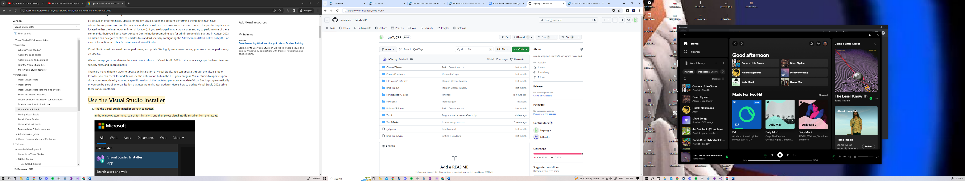](https://github.com/Jaspungus/IntroToCPP)

2. Merge Commit

https://github.com/Jaspungus/IntroToCPP/commit/b01fc28fb43f3d87e2736458fc4b53cc6fe4ce06

3. Pull Request

I’m not fully sure what I have to do here. Hope this is right.

[Pull Request Test by Jaspungus · Pull Request #1 · Jaspungus/IntroToCPP (github.com)](https://github.com/Jaspungus/IntroToCPP/pull/1)

4. Resource List

Besides AIE resources I used these videos to help me better understand how to use Git.

<https://www.youtube.com/watch?v=8Dd7KRpKeaE>

<https://www.youtube.com/watch?v=0nzJXJAhlsk>

5. Description of Challenges

The version control was mostly fine to work with. I’ve used git a tiny bit before, but always in a very limited capacity. The primary challenge I encountered occurred when I started Task 4 on my home computer, which as running an older version of Visual Studio. Everything pulled and ran on my computer and it pushed to main fine, but when pulling it to the school computers certain files needed to be reformatted to work with Visual Studio 2022. This was thankfully a small issue and I resolved it by letting Visual Studio reformat and change what it needed to. I then updated my personal computer’s version of Visual Studio to ensure parity in future. I also got briefly stuck on

6. Description of Weaknesses

My biggest weakness around git is definitely around branches and merges, which I still do not fully understand. I will try to resolve these by watching researching and learning from more resources around using Github in teams, especially as this will be a major component of the end of year group assessment. Another weakness I have is that I do not push changes frequently enough, resulting in several features being updated at once and unhelpful descriptions as I usually forget exactly what I’ve worked on throughout the day. I will work to upload changes with each separate feature I work on, so that others are better able to understand and approve my work. Once again this will be especially important for group projects.

2 Commits for each task.

Task 1:

<https://github.com/Jaspungus/IntroToCPP/commit/b9279b810e8849f797435ea416aebc99e8bdd8cd>

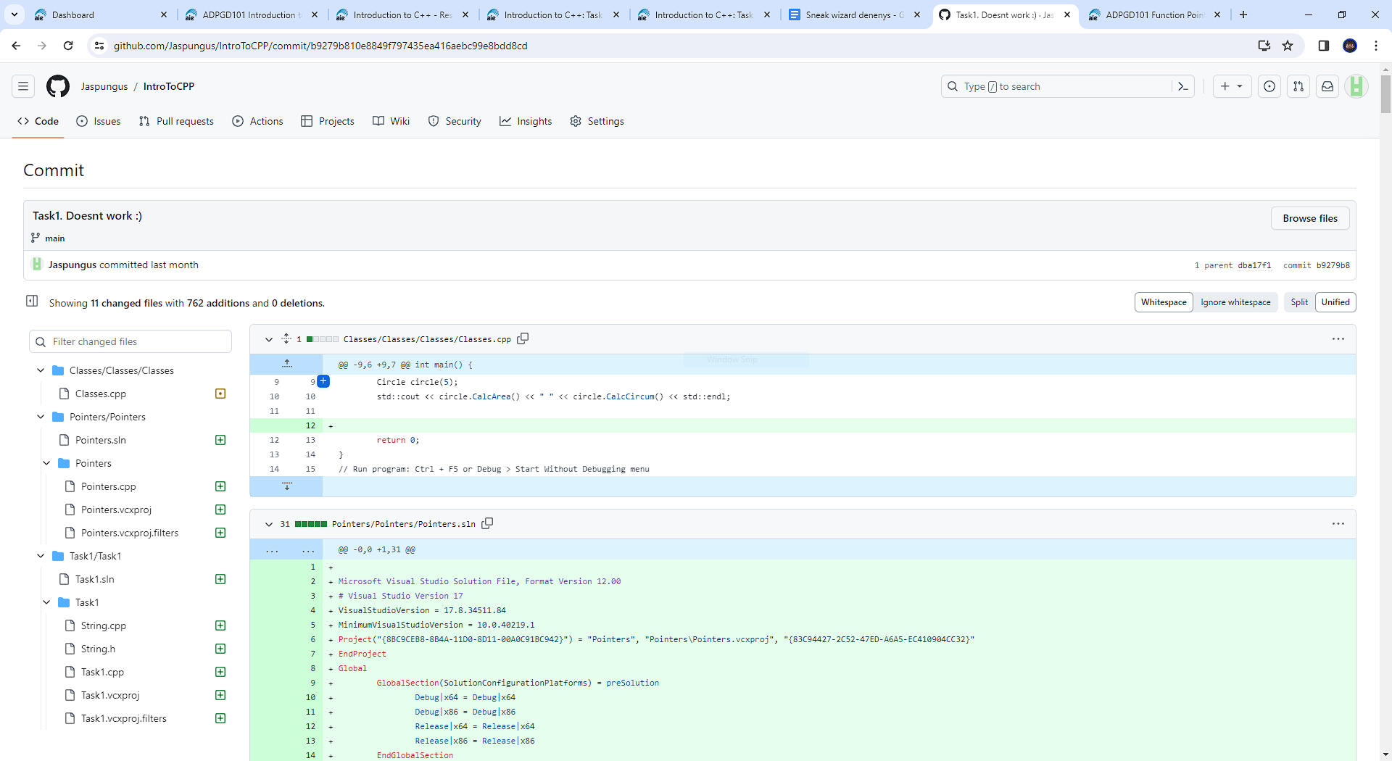

<https://github.com/Jaspungus/IntroToCPP/commit/f8b6af1be5e6537035af16eb97b4743b88a149ad>

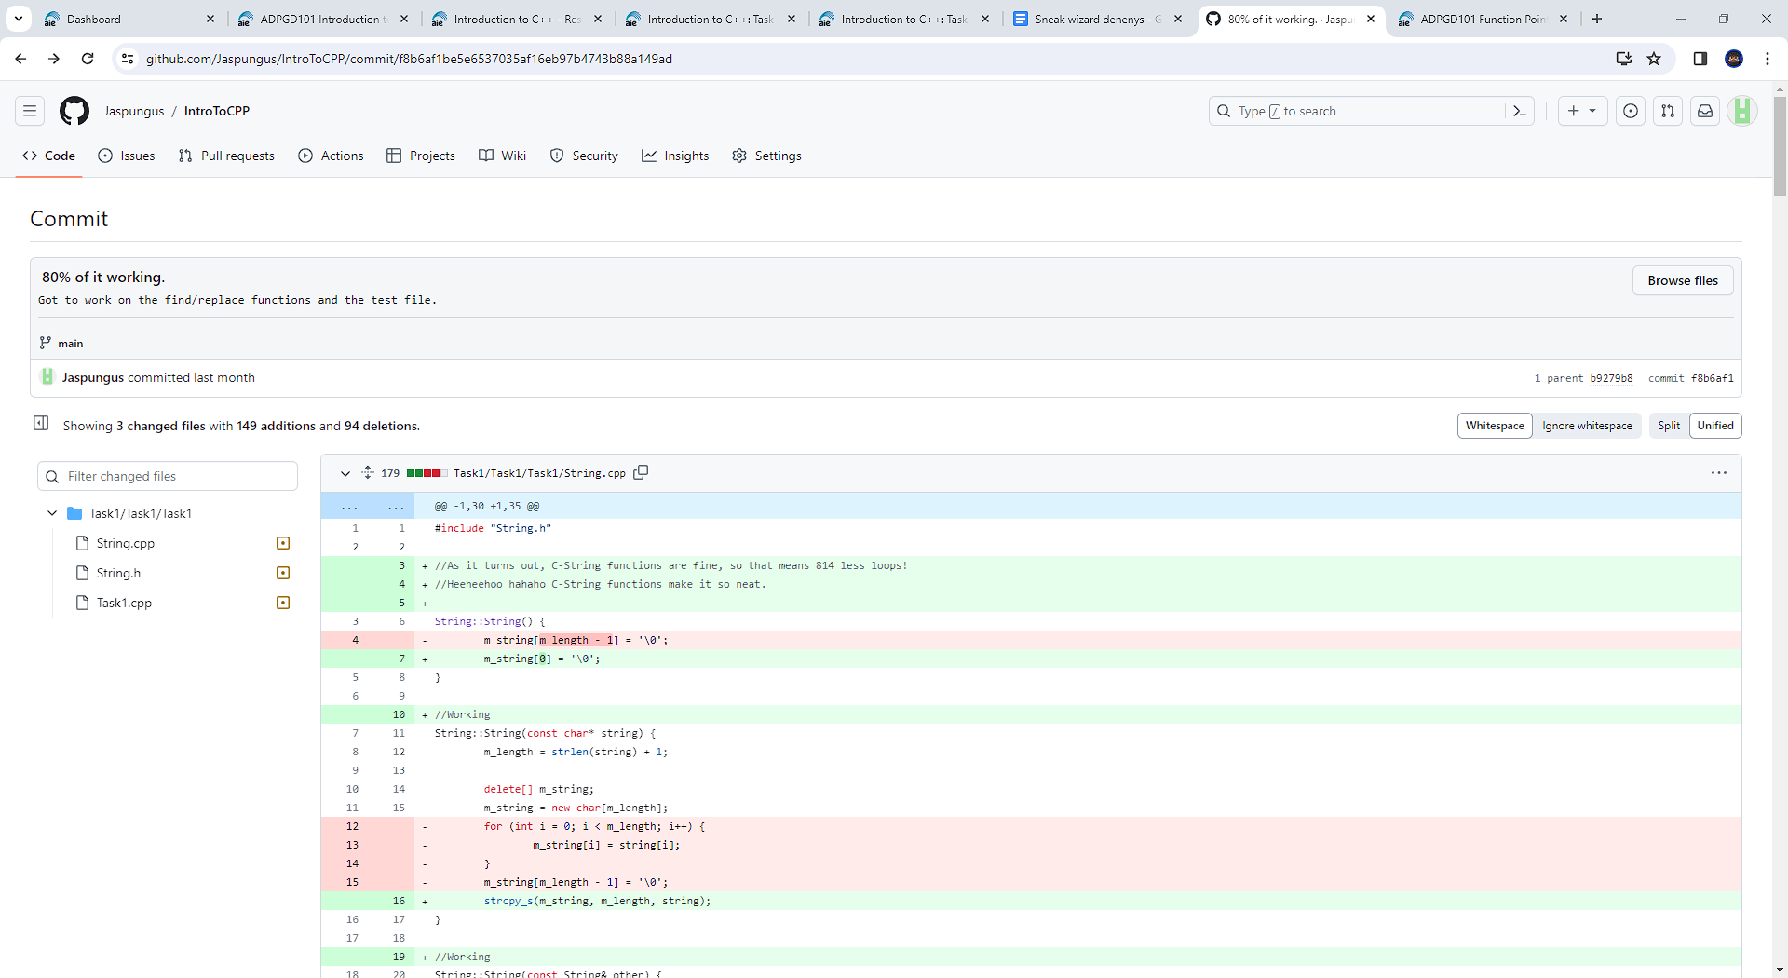

Task 2:

Perhaps problematically this was done in my Task1 solution, because it was all the same code. But this is the first commit where proper testing began.

<https://github.com/Jaspungus/IntroToCPP/commit/5c6b857dbae083ca9eb22164957da11285796dc4>

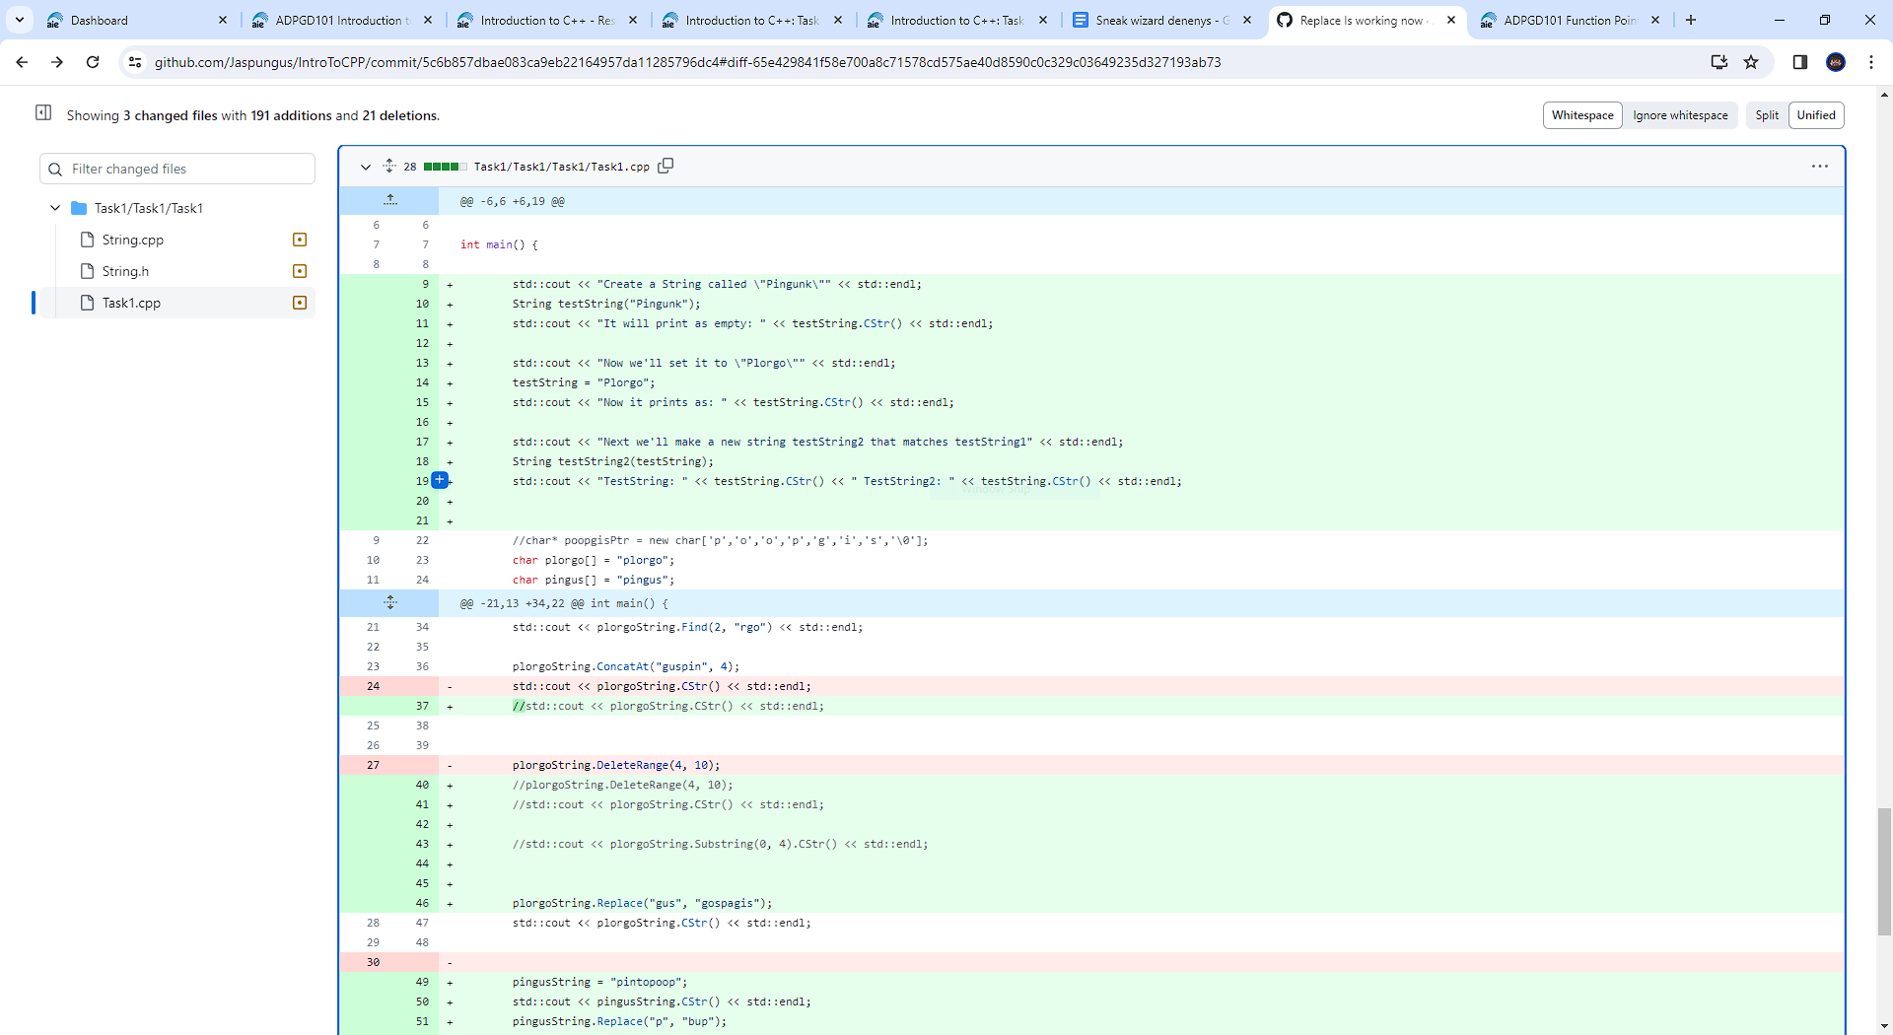https://github.com/Jaspungus/IntroToCPP/commit/c66d9e36d220db20a0345d3e1dfe033017dae72d#diff-65e429841f58e700a8c71578cd575ae40d8590c0c329c03649235d327193ab73

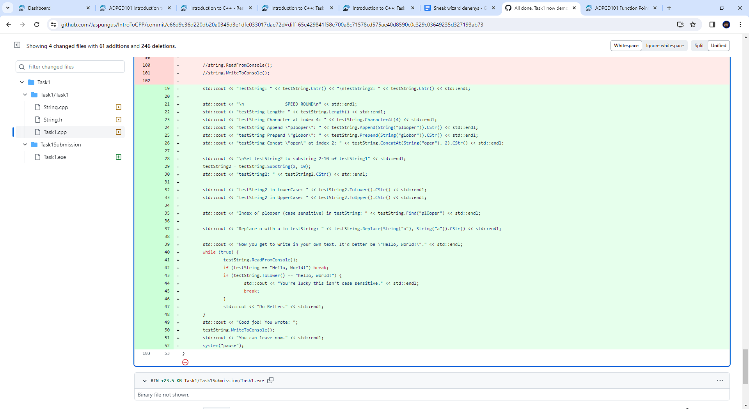

Task 3:  
[https://github.com/Jaspungus/IntroToCPP/commit/ad81b37cab33145d886e012c1f59e0a467dfcbd6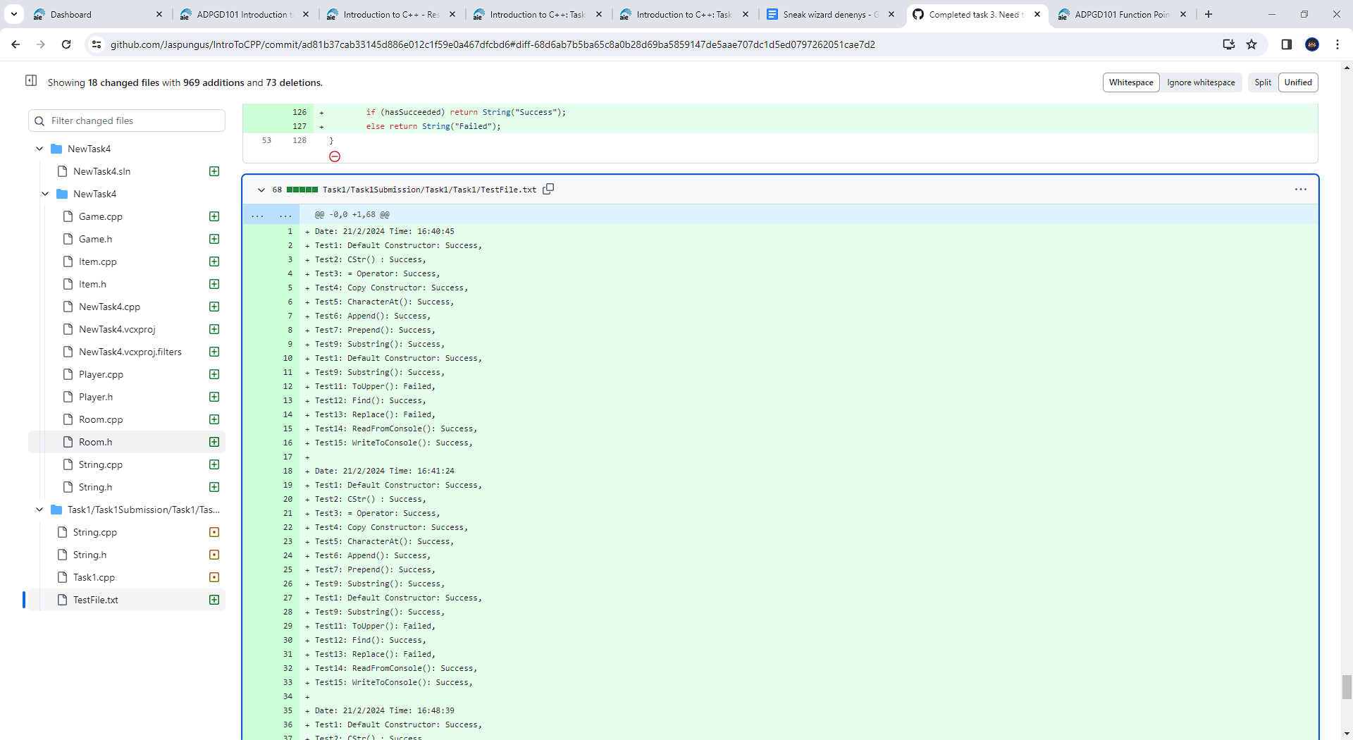](https://github.com/Jaspungus/IntroToCPP/commit/ad81b37cab33145d886e012c1f59e0a467dfcbd6)

<https://github.com/Jaspungus/IntroToCPP/commit/83e1a07899edcc8a7cc8bb54e74889a2691e24c8>

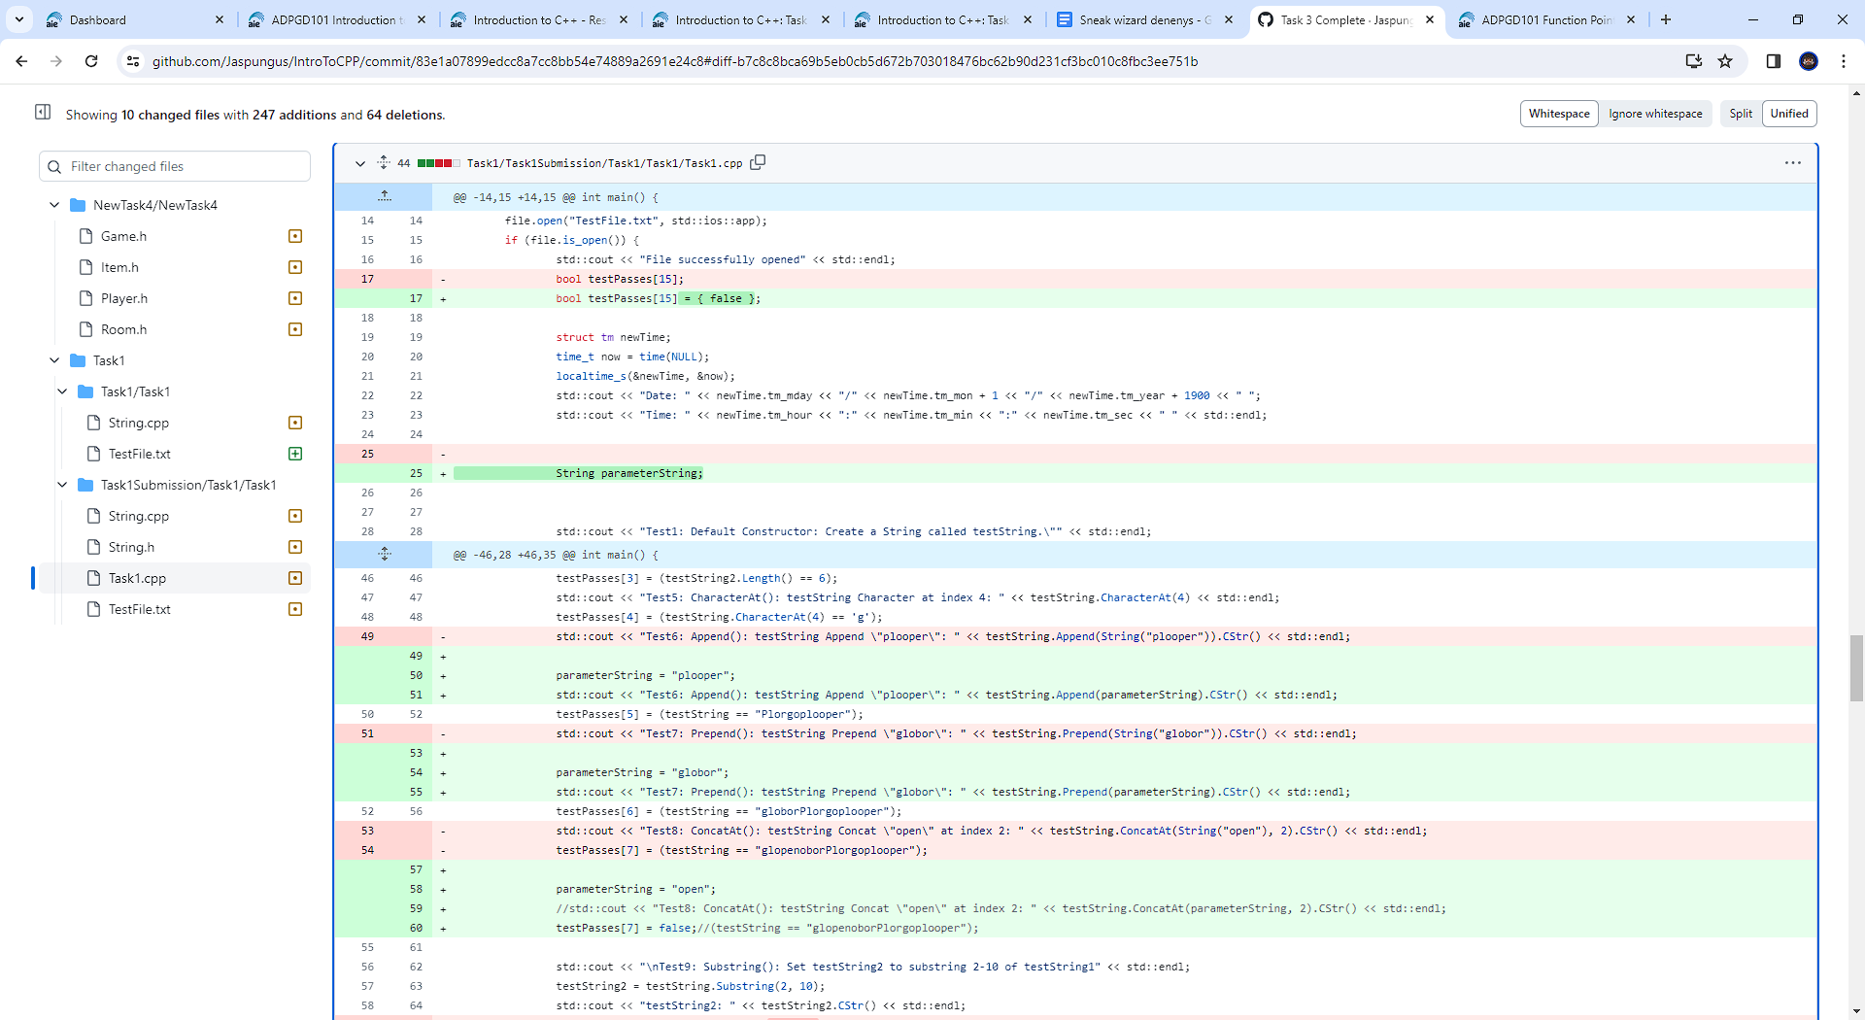

Task 4:

There are many more than 2 commits to this one. These are from the Task 4 I actually went with, rather than the 2 or so I did not. Also some of these commits were made from home on my personal account Jeffersby, rather than my school account Jaspungus in case you’re confused.

<https://github.com/Jaspungus/IntroToCPP/commit/a699ca1849893371c432e96278612df813099e04>

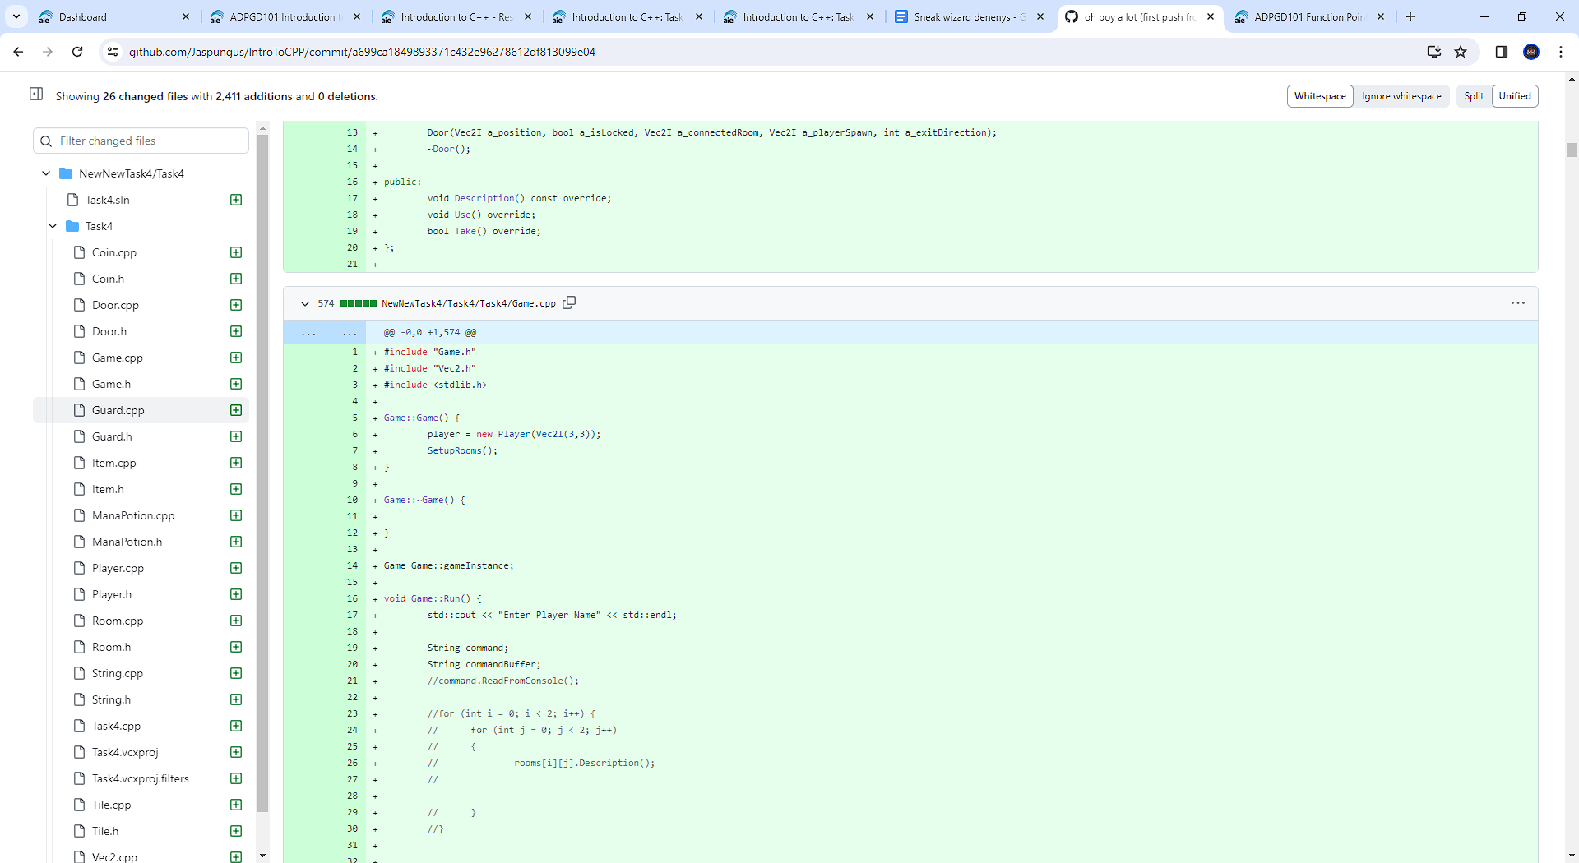https://github.com/Jaspungus/IntroToCPP/commit/b8f6b26c93f1055c04b294d3e746d64465b97ef7

